Aim: To use Amazon Comprehend to perform sentiment analysis on text data
Theory:
- Amazon Comprehend:
A managed NLP service by AWS that uses machine learning to discover insights and relationships in text such as entities, key phrases, language, and sentiment.
- Sentiment Analysis:
A text-classification technique that determines the emotional tone behind a body of text. Comprehend outputs a primary sentiment label and associated confidence scores.
- AWS SDK (Boto3):
The official Python interface for AWS services. It allows direct interaction with Amazon Comprehend APIs from a notebook environment.

Procedure:
Step 1: Launch a SageMaker Notebook Instance
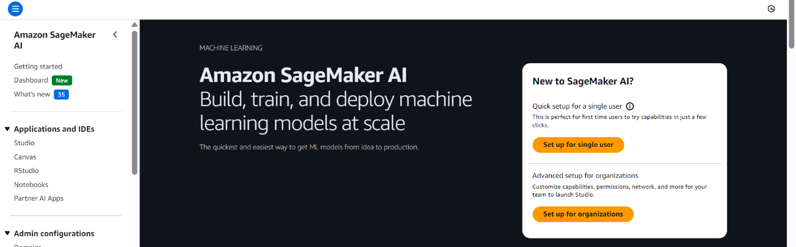
- Open the AWS Management Console and navigate to Amazon SageMaker.

- Create a new Notebook Instance (e.g., data-preprocessing-lab).
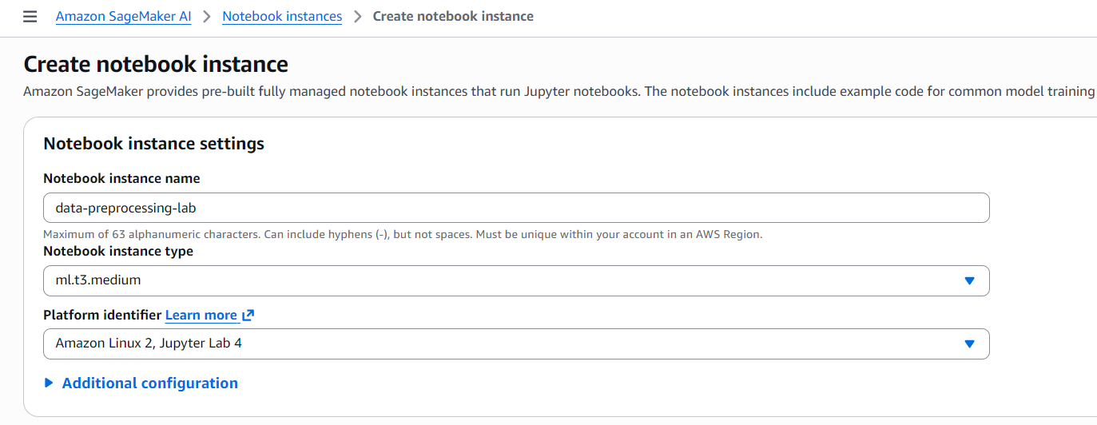
- Choose instance type ml.t3.micro (cost-efficient for small datasets).
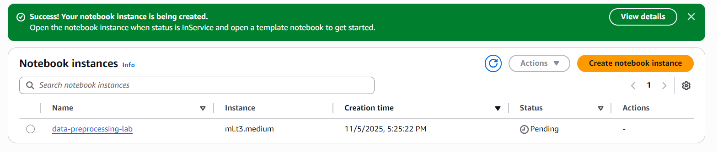
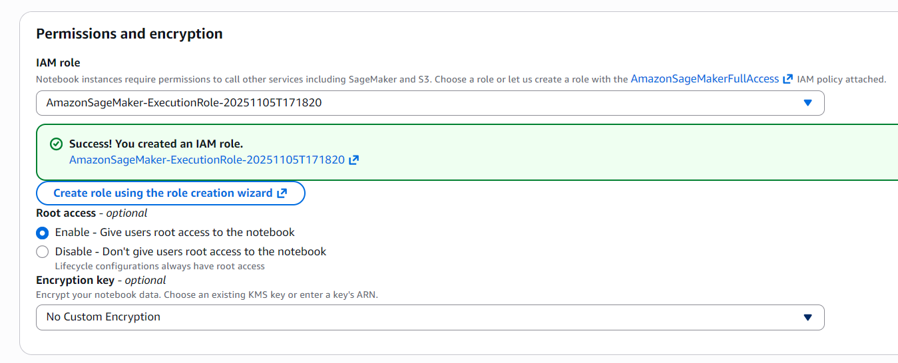
- Create an IAM role with S3 full access and Comprehend full access and attach it.

- Once the status is InService, click Open Jupyter to begin.

Step 2: Import Required Libraries and Create the Comprehend Client

Step 3: Define Text Samples – You can input raw text strings, or analyze text stored in a Pandas DataFrame.
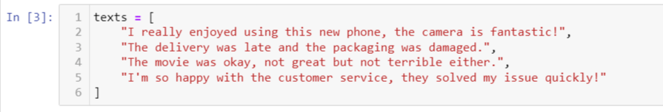
Step 4: Perform Sentiment Analysis – Amazon Comprehend offers both single-string and batch analysis methods.
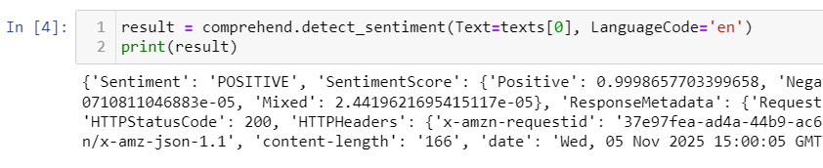
- Single text sentiment

- Batch sentiment for multiple texts
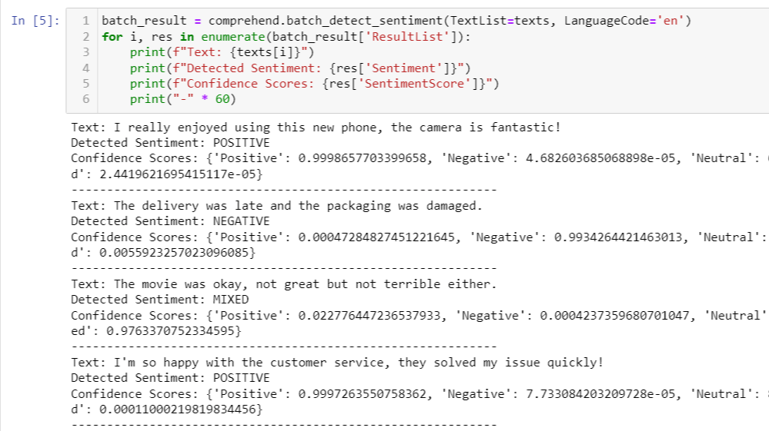
Step 5: Create a DataFrame for Better Visualization
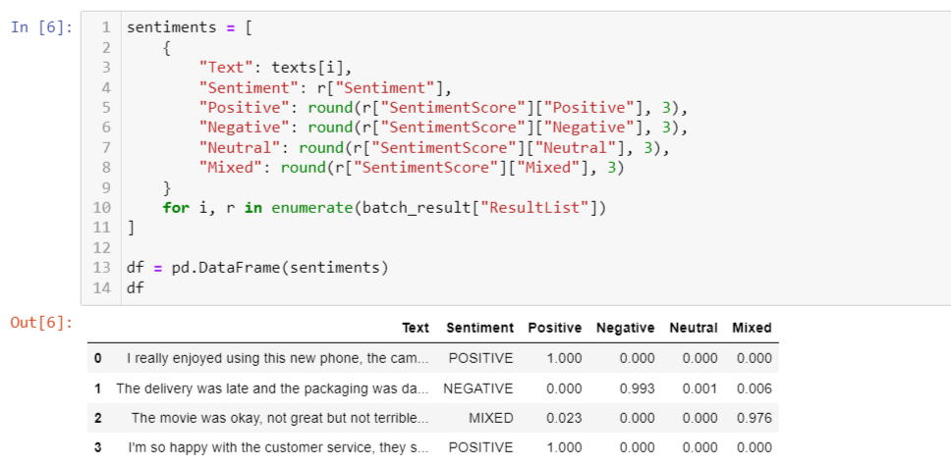
Step 6: Interpret Results
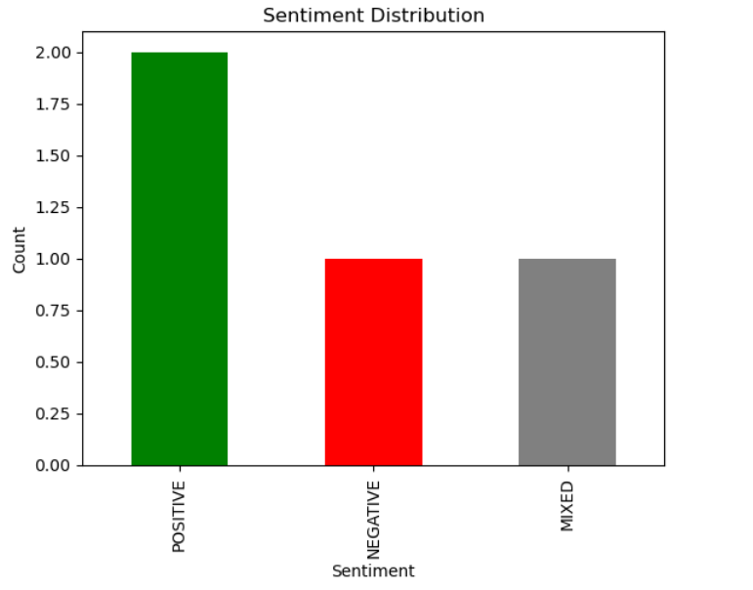
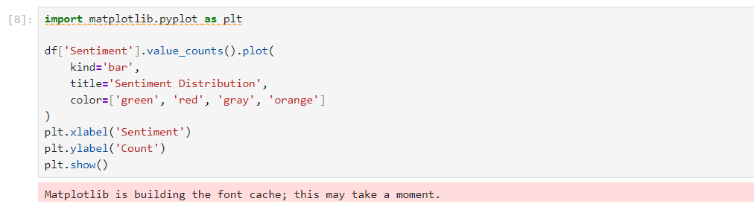

Conclusion:
In this lab, we successfully used Amazon Comprehend to perform sentiment analysis on text data.
We created a Comprehend client, analyzed multiple text samples, and interpreted both the overall sentiment labels and the associated confidence scores.
This lab demonstrates how AWS Comprehend can rapidly add natural language understanding capabilities such as sentiment detection without requiring any machine-learning model training.

